24615 – Josias Rodrigues de Souza

**Portfolio Report**

Among the options presented for the assignment , making a portfolio was the option chosen by me. As I am a bass player , I thought it was interesting to make a portfolio about myself. Being able to show a little of my musical history.

The Portfolio was created using the Sublime Text tool. This IDE(integrated development environment) is a text editor developed in C++ that is used to create websites. Because it is light, it does not affect the computer’s RAM memory. For this and other reasons it is a highly recommended tool.

The Doctype chosen for the design was HTML.The color sequence and the codes of the these colors were selected with the help of the website HTML Color Codes .

The portfolio home page is a small presentation , containing Bio and 4 navigations links(Music Projects , Songs , Videos , Contact ) in addiction to some photos. The ‘head’ function was used to define the top of the page and ‘title’ to name it. ‘divs’ (divisions) were used to structure the page and also the ‘style’ attribute to affect content , width, alignment, font-size, colors. For the style , frames are created to facilitate the visual configuration. In CSS format with the use of several functions such as: Color , font-size , text-allign, text-decoration-color, padding, justify-content, font-color, width, height, columns, float. Another way to adjust the font size is using the ‘h’ command and a number next to it, the bigger the number, the bigger the font(h2 for example).

To activate the frame , it is necessary to write ‘id’ and the name of the frame in quotes. For example <div=id “contacttext”>. The command ‘li’ ‘a href’ is responsible for creating the link to the others pages. It is what it possible to click on the link and open the next pages.To write paragraphs, the command used is ‘p’.

To insert the images into the portfolio , the command was used ‘img src’. It is possible to change the image size using the height and width functions for example. Inserting videos is a little more complex, the command is <video controls> <source src=”./videofile.mp4” type=”video/mp4”></video>. It is also possible to configure the screen size for the video visualization using the height and width functions. The inclusion of audio files, music in my case, is done in similar way to a video. The command used was <audio controls> <source src=”./audiofile.mp3” type=”audio/mp3”></audio>. In both, it is necessary to inform the type of file.In this case, files in mp4 and mp3 were used.

In order for the page have a footer, the function used is the <div id=”footer”> . It is a good way to indicate a copyright or put a signature.

The image below contains a flowchart of the portfolio navigation flow.

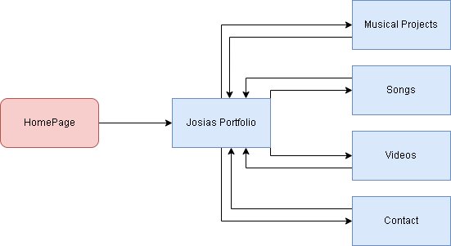

The project was always designed to be based on the principles of design, alignment, balance, contrast, emphasis, movement, hierarchy and harmony.

It was very interesting to be able to develop a project using the Sublime Text platform. The work done is simple and quickly. It is a light platform, which does not overload the machine.

Being able to tell a little about my musical history was hard work but also very pleasant. It is really nice when I acquire a new knowledge like that.

**Bibliograpy:**

https://htmlcolorcodes.com/

https://www.ufsm.br/pet/sistemas-de-informacao/2017/01/31/porque-utilizar-o-sublime-text/

https://www.alura.com.br/artigos/sublime-text-um-dos-melhores-editores-de-codigo

https://www.w3schools.com/html/default.asp